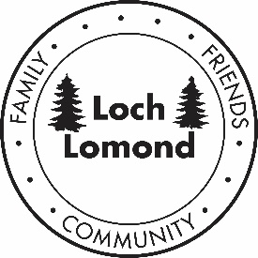

December 23, 2021

Dear LLPOA Members and Families,
Merry Christmas and Happy New Year to all. As I end my term as the LLPOA president, I would like to personally thank the board members and all our members who helped and guided me through the last five years. I accepted the position without much knowledge of the history and the day-to-day operations of the LLPOA, but after five years, I understand that the LLPOA and Loch Lomond is really about Family, Friends and Community as shown in our current logo.
Loch Lomond is a special place with so much to be thankful for and it has not been easy the last two years with the Covid Pandemic. We all should be thankful for the help and support of my team of Bryan, Suz-Anna, and Gary during this trying time. As a team, we made tough decisions that were always in the best interest of the LLPOA and its membership. I believe there is still the spirit of family and friendship that brought us here in the first place and that will live on for generations. We all look forward again to the laughter heard from deck to deck, Friday night Bingo and of course our favorite dinners.
I would especially like to thank my wife and family for their support and help during my term. Somehow when things were not going so well, they always seemed to be there to help. I look forward to spending more time with my four grandchildren, our extended family, and friends for years to come.
I feel blessed to have met so many nice people over years that I now can truly call my friends. Please support our new board as they take over the operation of the LLPOA and help when you can to keep Loch Lomond the special place, we all love and cherish.

Sincerely,
Dennis Dorn

